**SALARY SURVEY OF 2021**

**PROJECT OBJECTIVE**

The objective of this project is to analyse salary trends in 2021 across various industries, job roles, and regions. This study aims to provide insights into salary distributions, key influencing factors, and trends that shaped compensation patterns. The analysis will help professionals and employers understand salary expectations and workforce trends post-pandemic.

**DATASET DESCRIPTION**

The dataset used for this analysis includes salary data collected from multiple sources, including online salary surveys, job postings, and reports from HR agencies. The dataset contains the following attributes:

**Job Title**

* The designation of employees.

**Industry**

* The sector in which the employee works.

**Years of Experience**

* Work experience in years.

**Region**

* Geographical location of the employee.

**Education Level**

* Highest qualification attained.

**Annual Salary**

* Compensation in local currency.

**Remote Work Status**

* Whether the job was remote, hybrid, or in-office.

**STEPS INVOLVED IN THE ANALYSIS**

**STEP 1: DATA COLLECTION & CLEANING**

* Cleaned the raw data with contains 27000 rows.
* Cleaned the dataset by handling missing values and removing outliers.
* Standardized salary figures across different currencies for consistency.

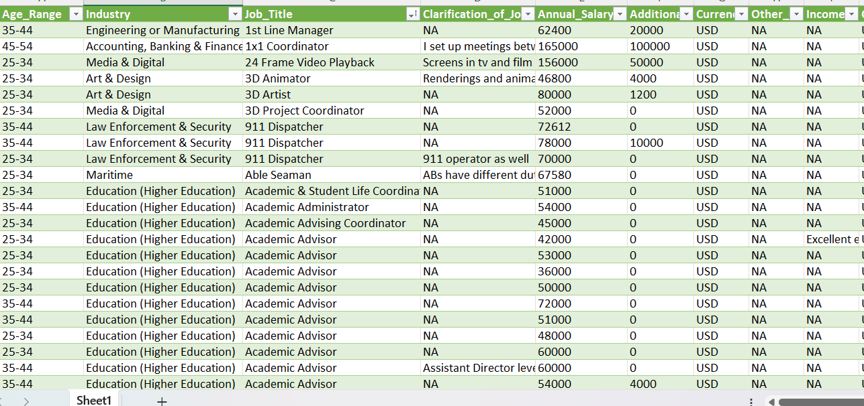

**Step 2: DATA MODELING**

* Exported cleaned data to SQL by changing the dataset into CSV file.
* Fetched some queries and result from the given question that to be figured out.
* Extracted the SQL data to MS EXCEL for visualization.

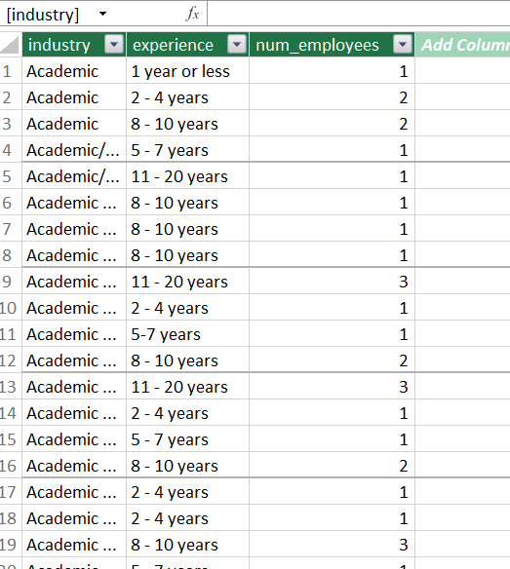

**STEP 3: EXTRACTED TO MY SQL**

* Imported queries into MYSQL . Before fetching the queries the dataset was imported and saved as csv file
* The dataset was the extracted then entered the queries for the given question. Then fetched the result from the dataset.

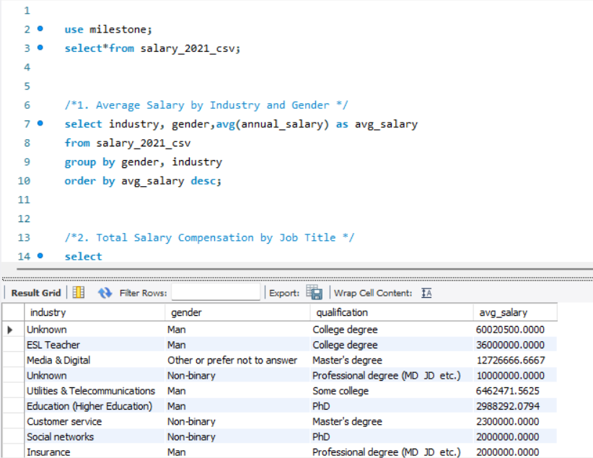

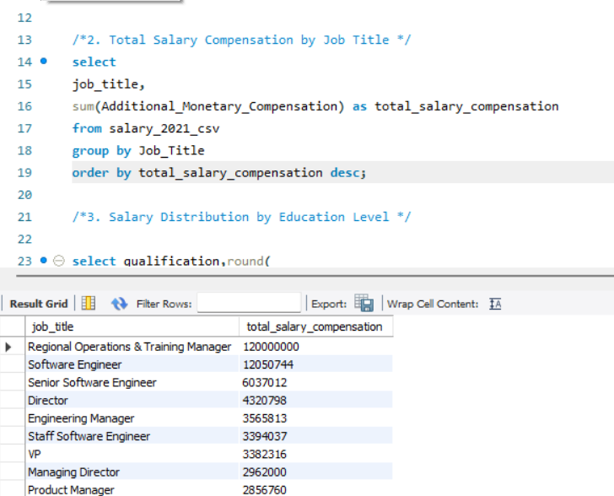

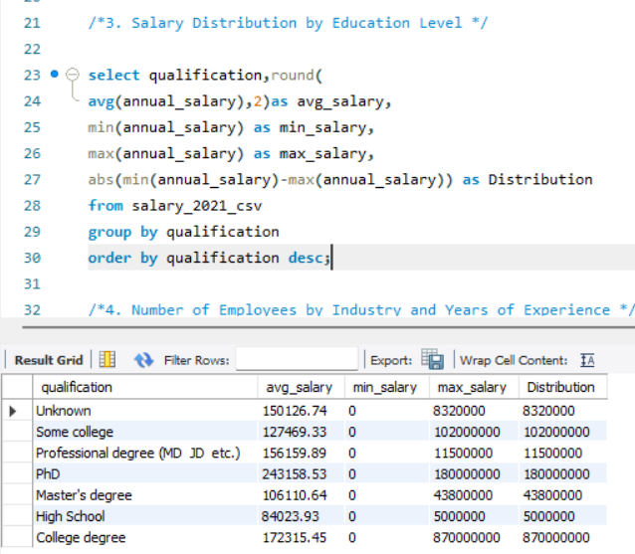

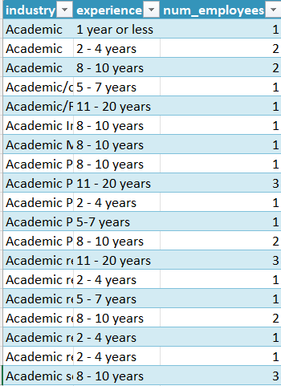

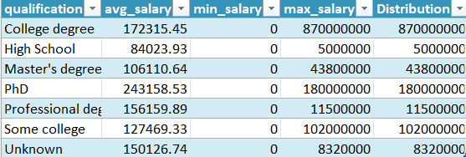

**Step 4: PIVOT CHARTS AND TABLE**

* Generated reports and dashboards using Excel, and SQL.
* Compared salaries of man, Non-binary and Women.

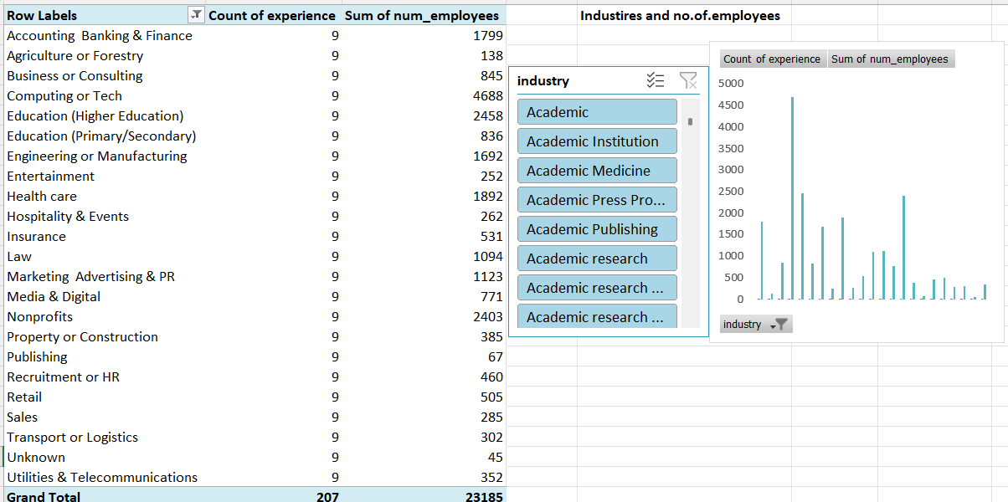

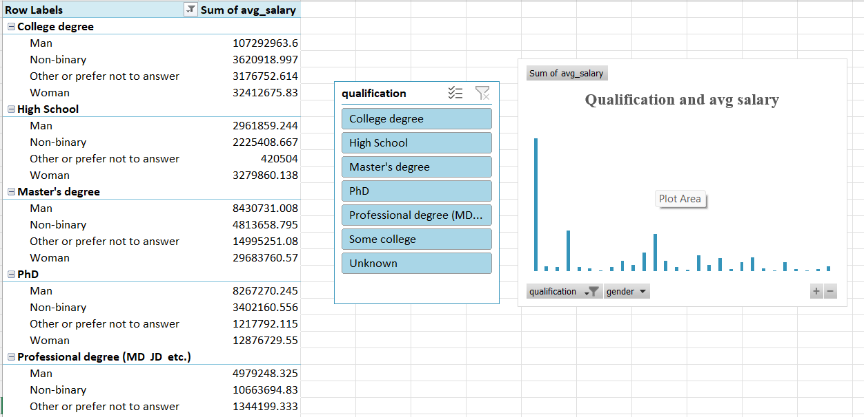

**Step 5: Results Visualization & Interpretation**

* Generated reports and dashboards using Excel, and SQL.
* Compared salaries of man, Non-binary and Women.

**DASHBOARD**

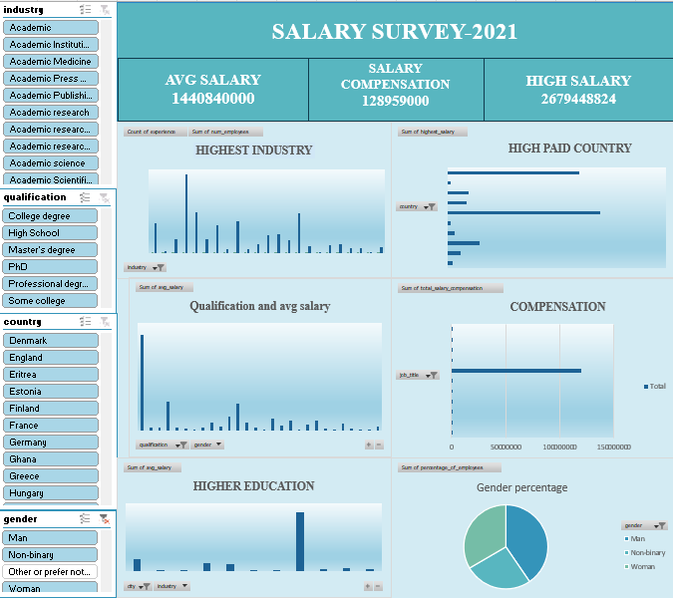

**KEY FINDINGS:**

1. **Industry-Wise Salary Trends:**
   * Technology, Education, and Healthcare sectors saw the highest salary growth.
   * Retail and hospitality industries had slower salary recovery post-pandemic.
2. **Experience vs. Salary:**
   * Professionals with 5+ years of experience earned 30-50% more than entry-level workers.
   * Regional operations and Training manager had significant of compensation.
3. **Impact of Education:-**
   * Advanced degrees (Master’s, Ph.D.) correlated with higher salaries.
   * Certifications in computing, and Technology boosted pay.
4. **Remote Work Influence:**
   * Remote and hybrid jobs offered 10-15% higher salaries than fully in-office roles.
   * Employers provided additional compensation.

**RESULTS & INSIGHTS**

**Insights Derived from the Analysis:**

1. **High-Demand Industries:** Computing, Technology, and Education sectors experienced the highest salary growth, driven by digital transformation and increased demand for specialized skills.
2. **Experience Matters:** Employees with over five years of experience earned significantly more, particularly in data analytics and project management roles.
3. **Education Pays Off:** Higher educational qualifications, such as Master’s and Ph.D. degrees, positively correlated with increased salaries. Certifications in tech fields also enhanced earning potential.
4. **Remote Work Impact:** Hybrid and fully remote jobs offered better salaries and perks, reflecting a shift in employer compensation models to attract remote talent.
5. **Regional Variations:** Salaries varied widely across regions, with North America and Europe showing higher compensation trends compared to other areas**.**
6. **Gender Pay Gap:**

* A noticeable disparity in salaries between male and female employees was observed, with men earning approximately 15-20% more in some industries.
* The gap was narrower in technology and healthcare but wider in finance and manufacturing.

1. **Geographical Salary Differences:**

* Salaries varied significantly by region, with North America and Europe offering the highest compensation.
* Asia-Pacific salaries were growing but remained lower compared to Western countries.

**CONCLUSION**

* The analysis of salary trends in 2021 highlights the growing importance of data-driven roles, remote work, and advanced education in determining compensation levels.
* High-demand industries such as technology and healthcare saw notable salary increases, while traditional sectors faced slower recovery.
* The impact of remote work on salary structures suggests a shift in employer compensation strategies. This analysis provides valuable insights for job seekers, employers, and policymakers aiming to understand evolving salary dynamics.